What is DevOps?
DevOps is a set of practices that combine both development (Dev) and operations (Ops).
DevOps aims to shorten the development life cycle by providing continuous integration and delivery (CI/CD) capabilities while ensuring high quality of deliverables.

Azure DevOps
- Collection of services for building solutions using DevOps practices
- Services included
  - Boards – tracking work
  - Pipelines – building CI/CD workflows (build, test and deploy apps)
  - Repos – code collaboration and versioning with Git
  - Test Plans – manual and exploratory testing
  - Artifacts – manage project deliverables
- Extensible with Marketplace – over 1000 of available apps
- Evolved from TFS (Team Foundation Server), through VSTS (Visual Studio Team Services)
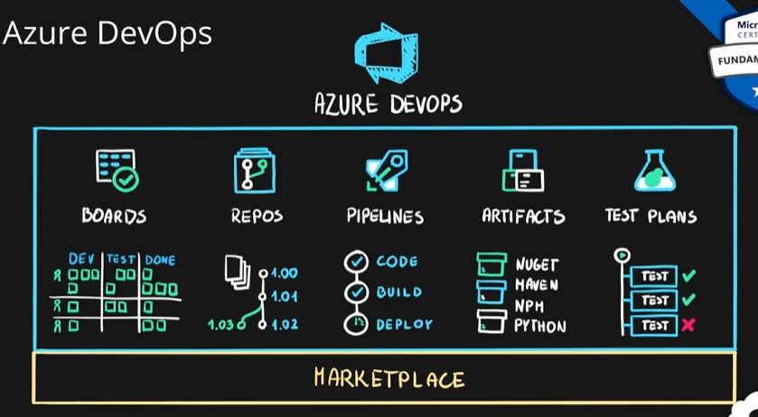

Azure DevTest Labs
- Service for creation of sandbox environments for developers/testers (PaaS)
- Quick setup of self-managed virtual machines
- Preconfigured templates for VMs
- Plenty of additional artifacts (tools, apps, custom actions)
- Lab policies (quotas, sizes, auto-shutdowns)
- Share and automate labs via custom images
- Premade plugins/API/tools for CI/CD pipeline automation
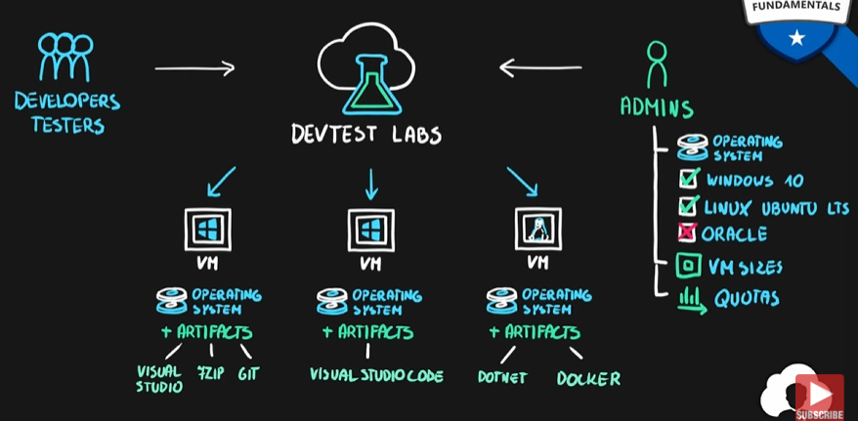

Summary
